**Post-apocalypse 3d project**

Undertaking the creation of a post-apocalyptic 3D model in Maya proved to be a challenging yet immensely rewarding project, becoming a litmus test for my proficiency in the program. The primary objective was to vividly depict the aftermath of an earthquake in a city, with a specific focus on intricately detailing a bedroom within this desolate and haunting environment. Embarking on the modeling journey, I harnessed the potent capabilities of Maya's mesh and sculpting tools, meticulously shaping the ruins of the city and the minutiae of the ravaged bedroom to evoke a visceral sense of destruction.

In the quest for realism, UV mapping emerged as a pivotal step in breathing life into the models. The meticulous application of textures and the unwrapping process were critical for achieving authenticity in the appearance of both the bedroom elements and the cityscape. Despite the inherent complexity of UV mapping, persistence and a commitment to learning enabled me to overcome challenges encountered during this phase. Watching tutorials emerged as an indispensable resource, providing not only solutions but also valuable insights that propelled the project forward with newfound confidence.

Traversing the learning curve in Maya, I encountered specific challenges in modeling various elements due to my initial proficiency limitations and I faced some challenges in renders where some of the textures weren’t shown. However, rather than being deterrents, these challenges became steppingstones for personal and technical growth. Delving into tutorials, learning on the fly, and actively problem-solving transformed stumbling blocks into opportunities to expand my skill set. Gradually, I overcame hurdles in crafting complex models, enhancing both efficiency and confidence in the intricate 3D modeling process.

The scene's atmospheric resonance hinged significantly on the nuanced lighting setup. Employing HDRI and rendering lights in Maya, I painstakingly curated the lighting to convey the eerie aftermath of a post-apocalyptic event. Experimenting with diverse lighting configurations, I aimed to capture the dynamic essence of a city in ruins. Ensuring that the interplay of light underscored the bedroom's setting and accentuated the specific details of destruction was crucial in articulating the narrative within the visual composition.

Every element in the scene, from the minutest debris to the sprawling city ruins, was meticulously conceived and constructed from scratch. This involved a rigorous conceptualization process that translated the abstract idea of a post-apocalyptic world into tangible, three-dimensional models. The bedroom, wreckage, and city ruins materialized as a result of an artistic investigation that underscored the project's originality and distinctiveness in the vast landscape of 3D modeling.

A series of work-in-progress photos meticulously documented the evolution of the models throughout the project. Serving as both a visual timeline and windows into the iterative creative process, these snapshots provided insights into how each model evolved, showcasing the integration of novel approaches and the continuous learning that defined the project's trajectory.

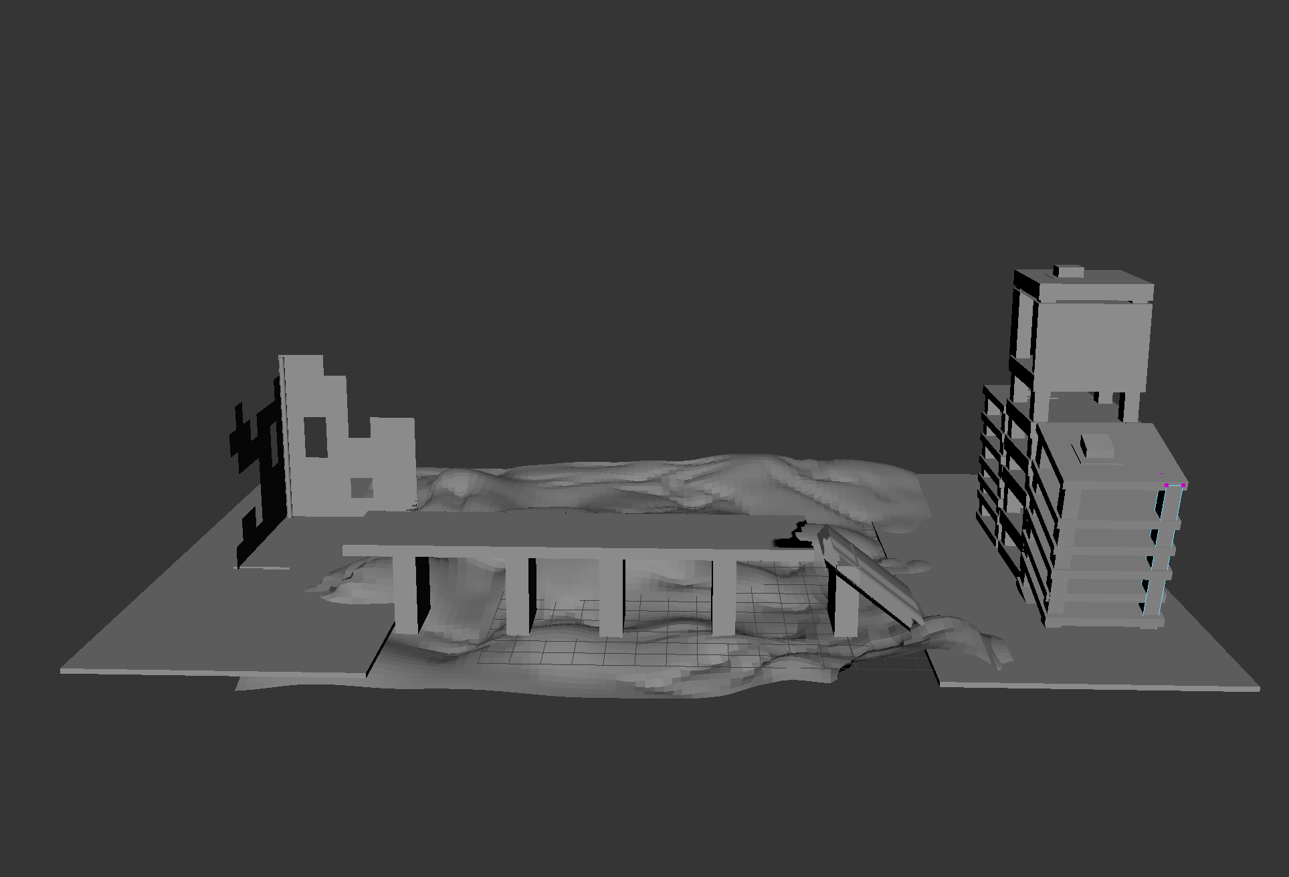

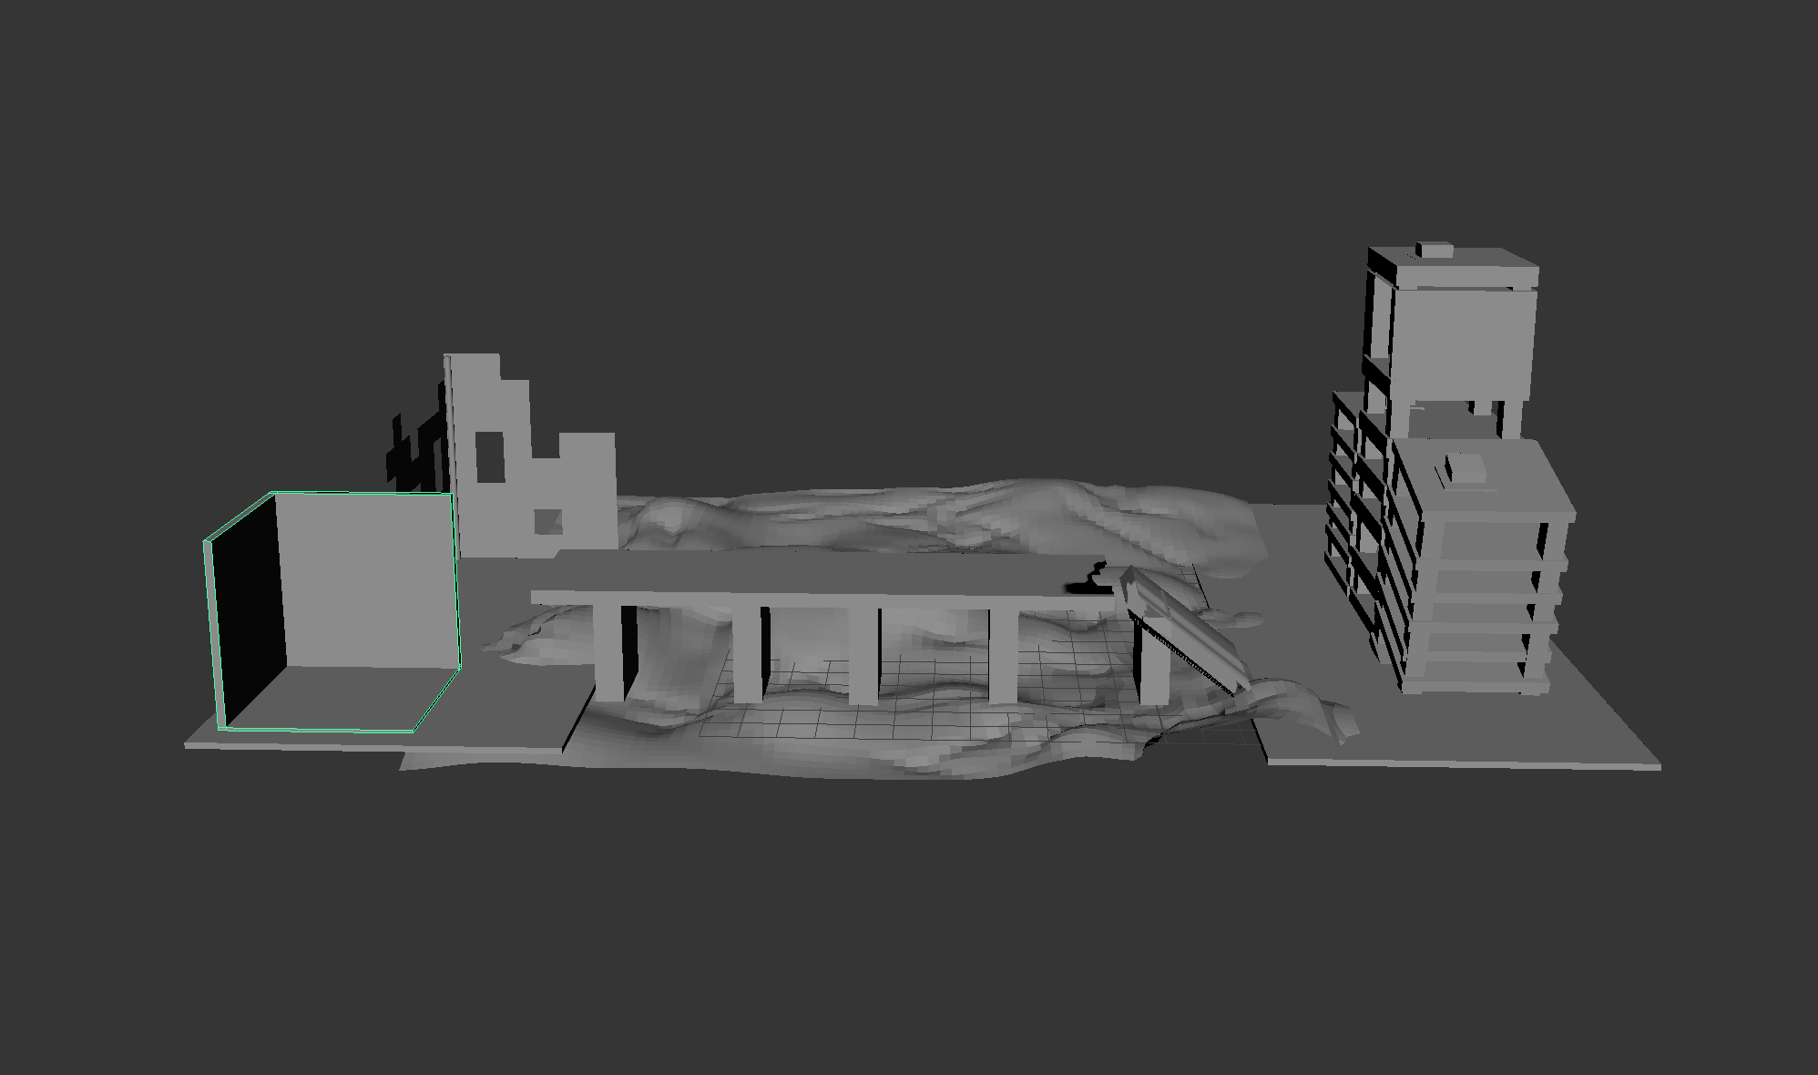

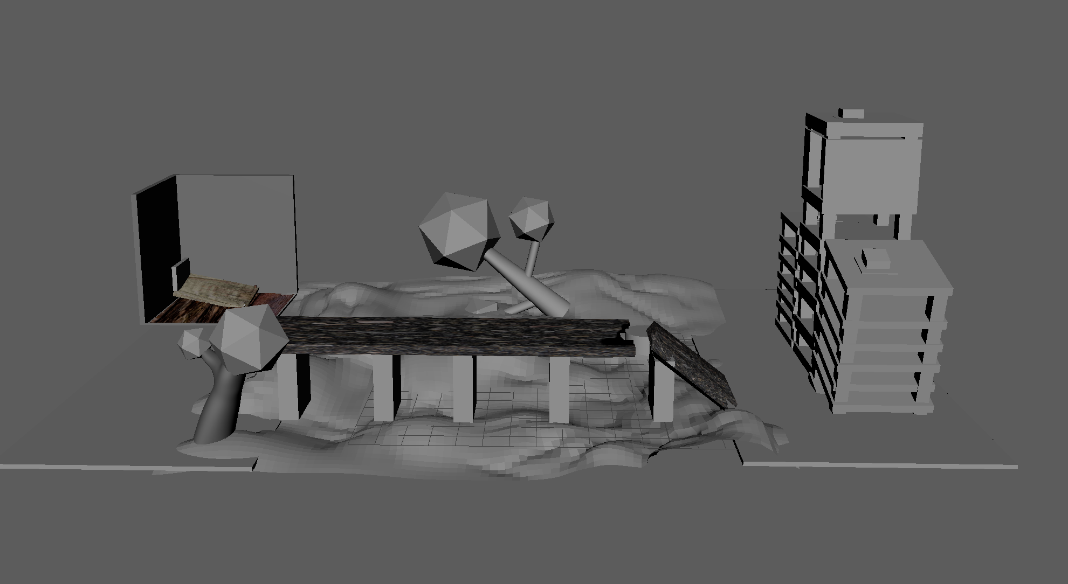

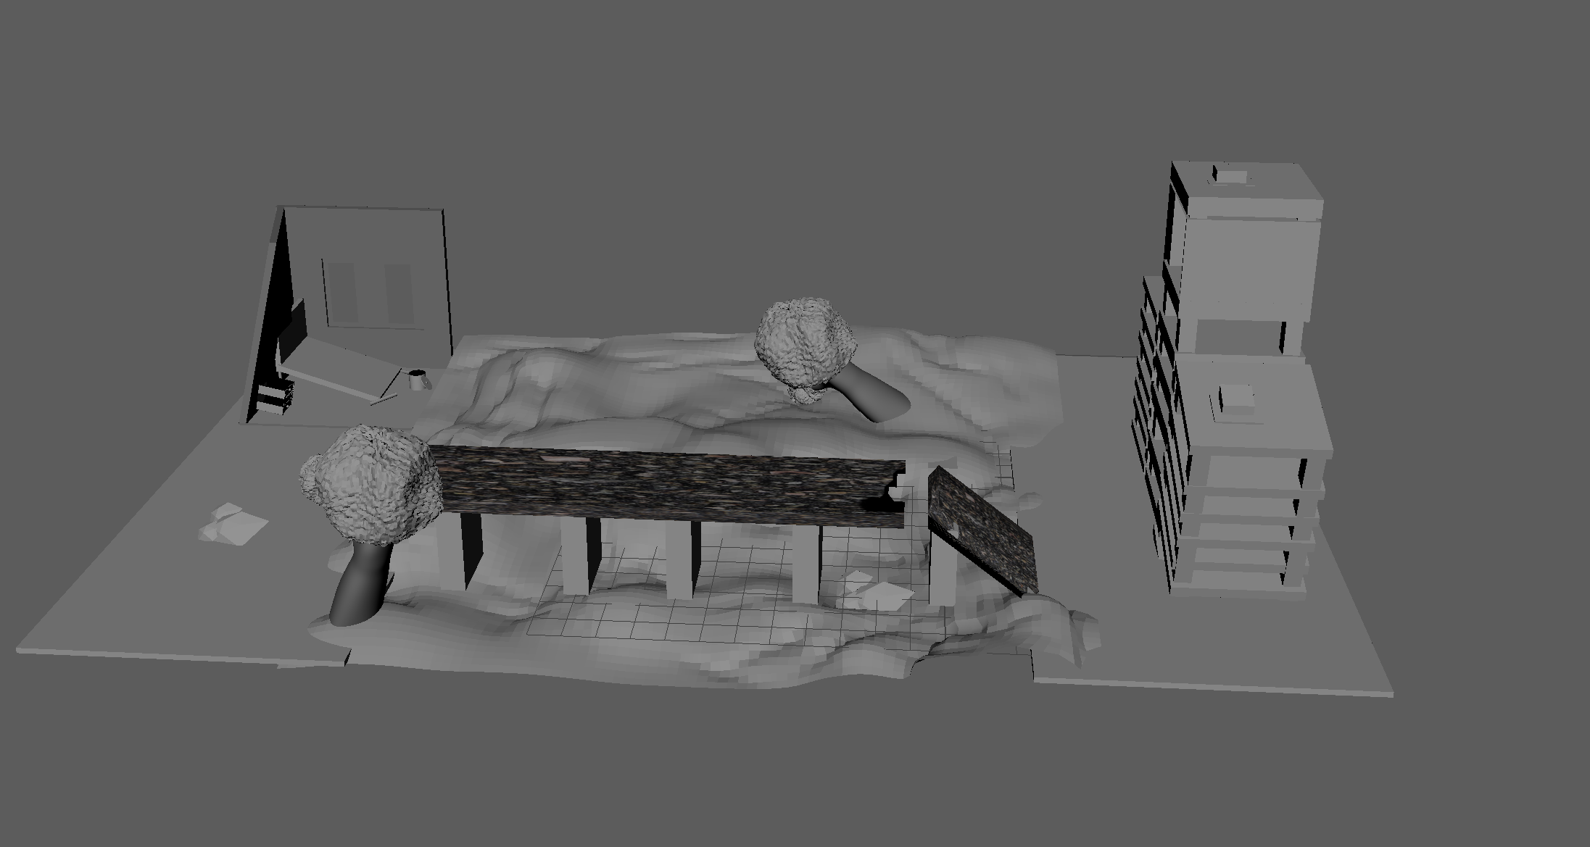

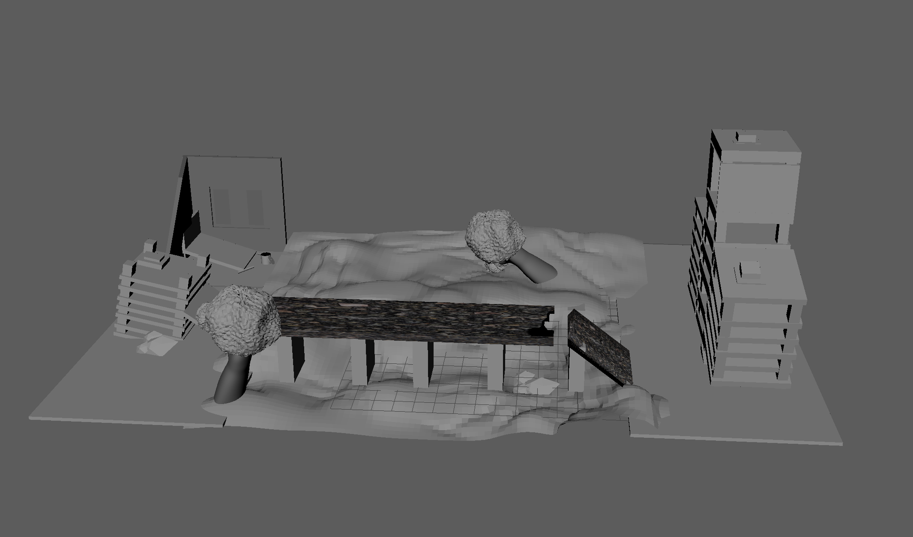

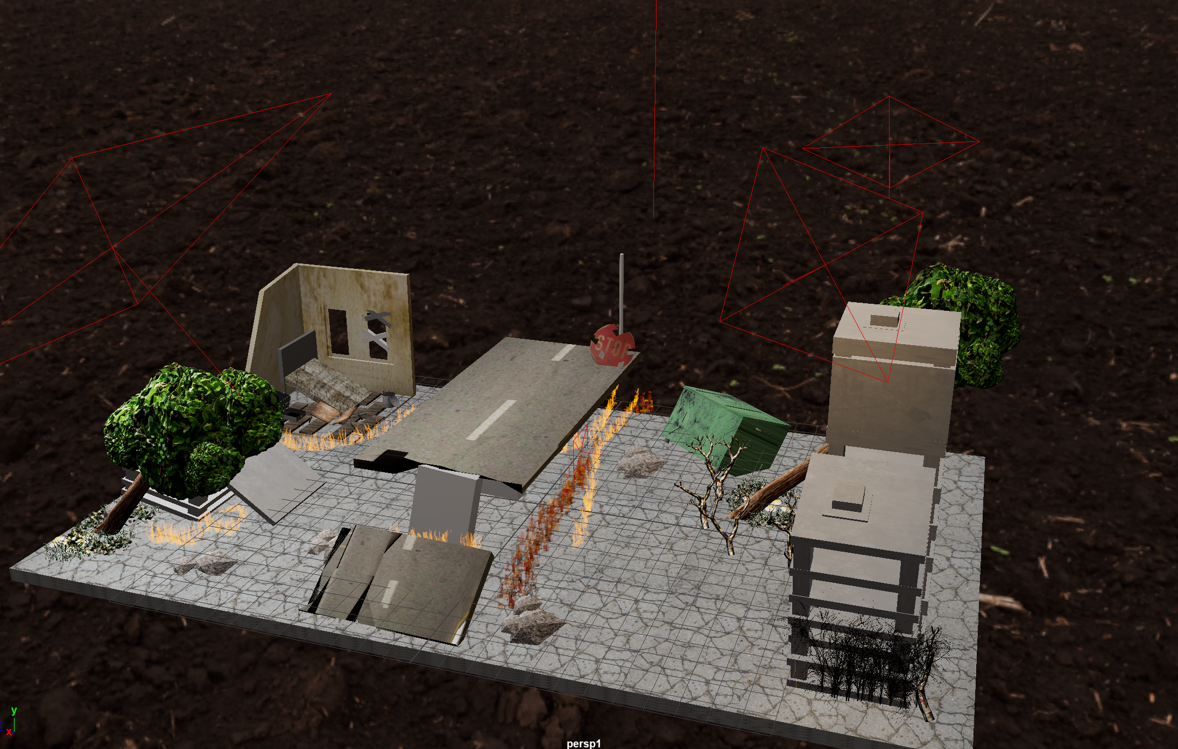

In conclusion, this 3D modeling odyssey became a testament to the transformative potential of hands-on, experiential education. From overcoming modeling intricacies to mastering UV mapping and lighting intricacies, the project encapsulated the spectrum of challenges and triumphs inherent in navigating the complexities of a sophisticated program like Maya. As the final textured model emerged, it not only depicted a post-apocalyptic scene but stood as a tangible manifestation of both personal and technical growth in the dynamic realm of 3D modeling.